Multivariate Linear Regression
Ml Activity 2

Antonio, Daniel
Electronics and Communications Engineering Department
De La Salle University - Manila
Manila, Philippines

Eco, Lance Randall Lim
Electronics and Communications Engineering Department
De La Salle University – Manila
Manila, Philippines
lance_eco@dlsu.edu.ph

Tan, Sidney Sheldon Urlanda
Electronics and Communications Engineering Department
De La Salle University - Manila
Manila, Philippines
sidney_tan@dlsu.edu.ph

Zarzoso, Aaron John Pascua
Electronics and Communications Engineering Department
De La Salle University - Manila
Manila, Philippines
aaron_zarzoso@dlsu.edu.ph

Abstract—This document represent the student’s lab report for experiment 2 of the course LBYCP29.
Keywords—octave; matlab; multivariate; linear; plots

Introduction
Matlab is a high level language created by MathWorks and is well-known as a computational software for various arithmetic operations as well as image processing, communications, control systems, and others [1]. Matlab is also a pay to use software which is why students are opt to use the free alternative “Octave”. Octave has a similar purpose and is cross compatible with Matlab [2]. Unlike in experiment 1 which dealt with Linear Regression, experiment 2 deals with simulating multivariate linear regression through the software “octave” or “matlab”. Multivariate Linear Regression is utilized to predict the value of a single or multiple responses from a set of predictors. In this experiment students are tasked to analyze multivariate linear regression by using gradient descent and normal equation while observing the relationship of the cost function, the gradient descent and the learning rate.

Instructions/procedure

Procedure 2.0
1. Plot the raw data: (a) housing prices with respect to living area; (b) housing prices with respect to the number of bedrooms before preprocessing.
2. Plot the preprocessed data: (a) housing prices with respect to living area; (b) housing prices with respect to the number of bedrooms after pre-processing.

Procedure 2.1
Observe the changes in the cost function happens as the learning rate changes. What happens when the learning rate is too small? too large?
What is the best learning rate that you have found?

Procedure 2.2
Using the best learning rate that you found, run gradient descent until convergence to find
1. The final values of θ = _______________
2. The predicted price of a house with 1650 square feet and 3 bedrooms. (Don't forget to scale your features when you make this prediction!)
House price = ________________

Procedure 2.3

In your program, use the closed form solution to a least squares fit formula to calculate θ.

Remember that while you don't need to scale your features, you still need to add an intercept term.

Once you have found from this method, use it to make a price prediction for a 1650 squarefoot house with 3 bedrooms.
Did you get the same price that you found through gradient descent?

Procedure 2.4
Provide your own data with at least 50 elements and at least 2 input features. Then, apply the procedures 2.1-2.3 performed in this experiment to your own data.

Data and results

Procedure 2.0
- (a)
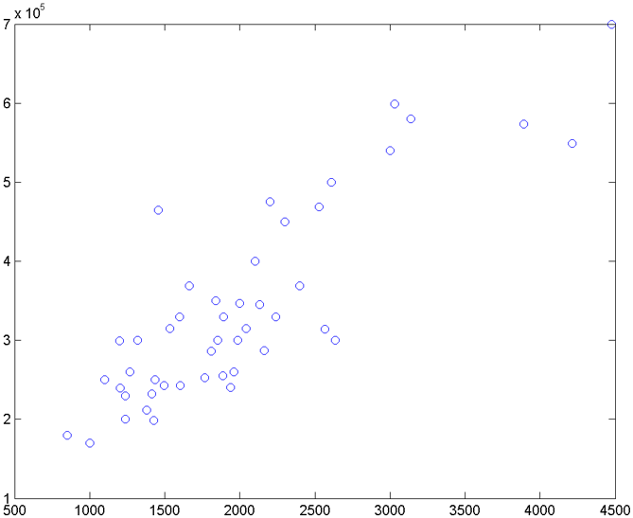
Fig. 1. Raw Data Plot of Housing Prices with
Respect to Living Area
(b)
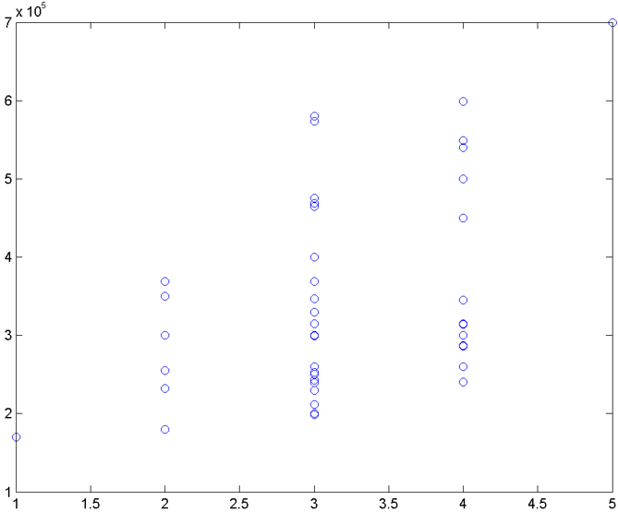
Fig. 2. Raw Data Plot of Housing Prices with Respect to The Number of Bedrooms Before Preprocessing.
- (a)
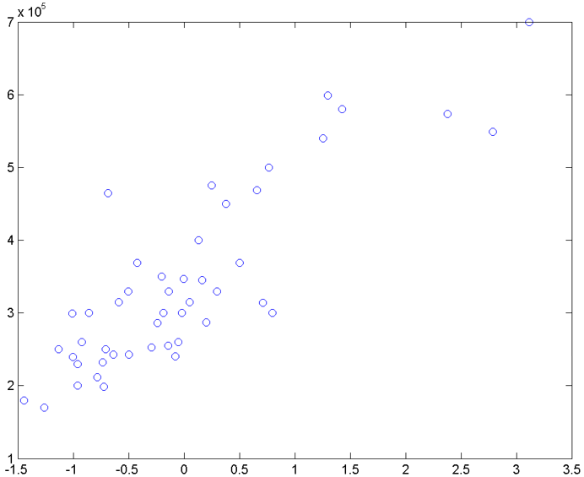
Fig. 3. Preprocessed Data Plot of Housing Prices with Respect to Living Area
(b)
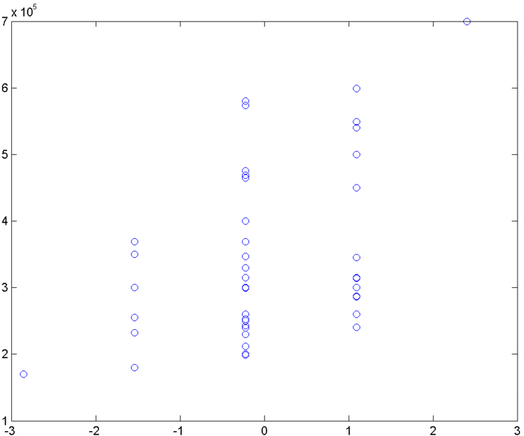
Fig. 4. Preprocessed Data Plot of Housing Prices with Respect to The Number of Bedrooms After Preprocessing.

Procedure 2.1
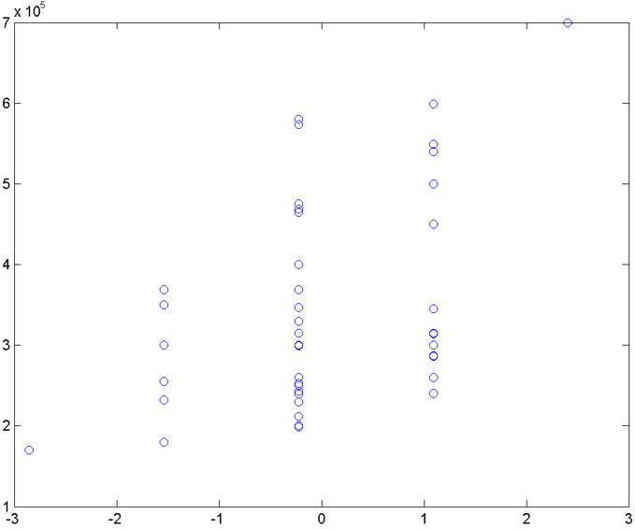
Fig. 5. Plot of learning curve rate of α=0.01.
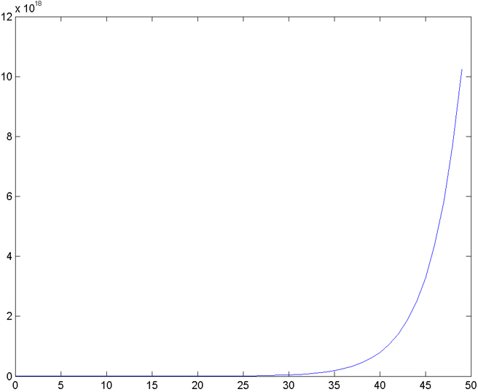
Fig. 6. Plot of learning curve rate of α=1.5.
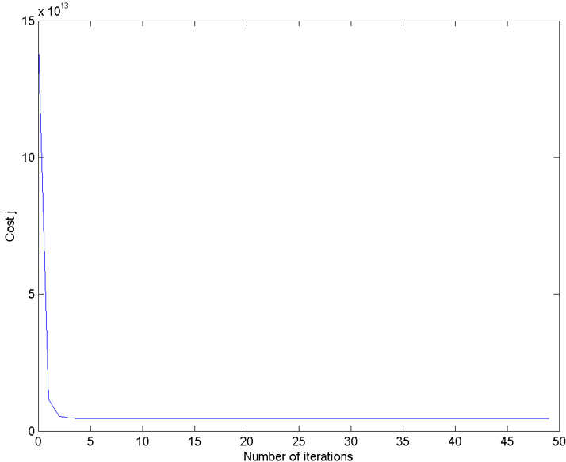
Fig. 7. Plot of learning curve rate of α=0.8.

The alpha (α) 0.01 in Fig.5 denotes the small learning curve rate while the alpha (α) 1.5 in Fig.6 denotes the large learning curve rate. Comparison between the graphs show that the graph of the smaller learning rate is more linear than the graph with larger learning rate which spiked at a latter iteration.
Best learning rate is 0.8 as shown in Fig.7.

Procedure 2.2
ϴ = [3.404126595744681e+05;1.106310500926826e+05; -6.649474084656331e+03]
House price = 2.930814643434721e+05

Procedure 2.3
ϴ = [8.959790954279870e+04; 1.392106740176292e+02; -8.738019112327724e+03]
House price = 2.930814643434721e+05
Same? Yes

Procedure 2.4
- Own Data
AGE | HEIGHT(in) | WEIGHT | AGE | HEIGHT(in) | WEIGHT
10 | 56.7 | 35.3 | 16 | 69.1 | 59.9
11 | 57.2 | 30.9 | 16 | 66.4 | 70.2
11 | 55.9 | 35.5 | 16 | 66.4 | 71.1
11 | 59.1 | 36.1 | 16 | 68.1 | 80.0
11 | 59.1 | 32.6 | 16 | 65.7 | 69.7
12 | 57.9 | 33.5 | 16 | 69.8 | 68.8
12 | 56.3 | 40.7 | 17 | 68.3 | 73.5
12 | 50.3 | 36.3 | 17 | 70.2 | 76.6
12 | 52.1 | 34.2 | 17 | 67.7 | 59.9
13 | 59.8 | 33.2 | 17 | 65.4 | 60.5
13 | 63.7 | 40.1 | 17 | 69.9 | 66.3
13 | 64.5 | 42.3 | 18 | 69.9 | 72.6
14 | 63.2 | 44.1 | 18 | 68.9 | 82.3
14 | 57.4 | 41.1 | 18 | 68.1 | 78.3
14 | 65.7 | 46.1 | 18 | 72.3 | 78.3
14 | 65.5 | 50.4 | 18 | 69.8 | 79.5
14 | 50.1 | 51.6 | 19 | 69.7 | 69.9
14 | 67.2 | 49.5 | 19 | 71.1 | 68.9
14 | 66.7 | 50.6 | 19 | 73.2 | 69.9
14 | 65.1 | 61.7 | 19 | 72.4 | 79.9
15 | 70.3 | 49.5 | 20 | 72.7 | 88.3
15 | 66.0 | 51.7 | 20 | 69.1 | 78.9
15 | 64.2 | 69.9 | 20 | 70.8 | 68.5
15 | 68.2 | 68.7 | 20 | 70.3 | 90.5
16 | 67.1 | 56.5 | 20 | 74.1 | 90.6
- Procedure 2.1
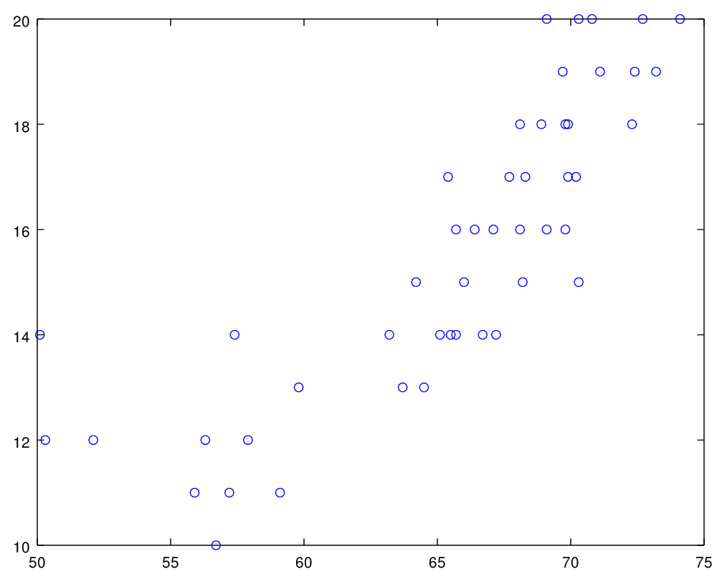
Fig. 8. Raw Data Plot of Age with
Respect to the Height
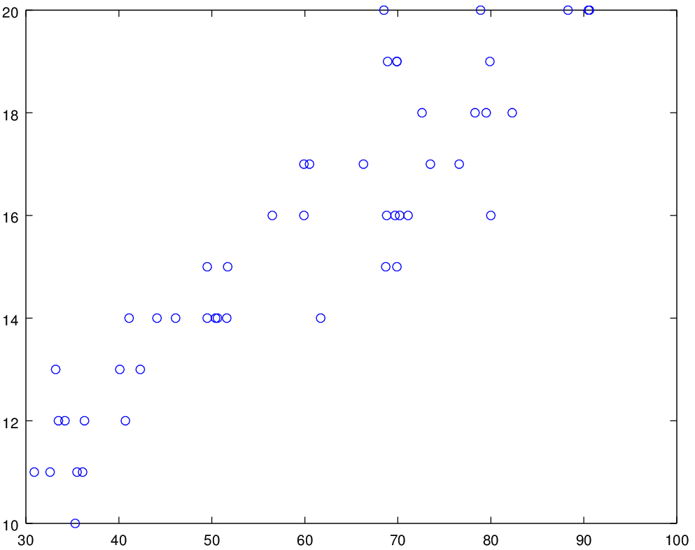
Fig. 9. Raw Data Plot of Age with Respect to the Height Before Preprocessing.
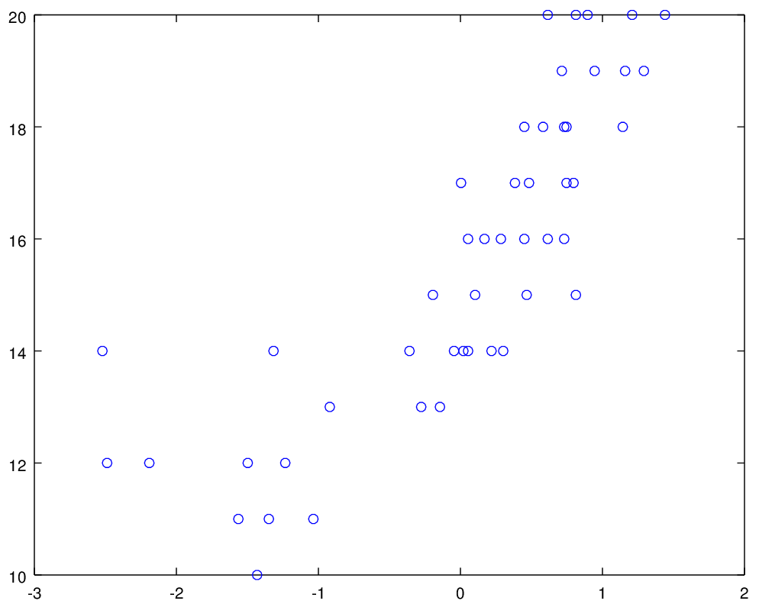
Fig. 10. Preprocessed Data Plot of Age with
Respect to the Height
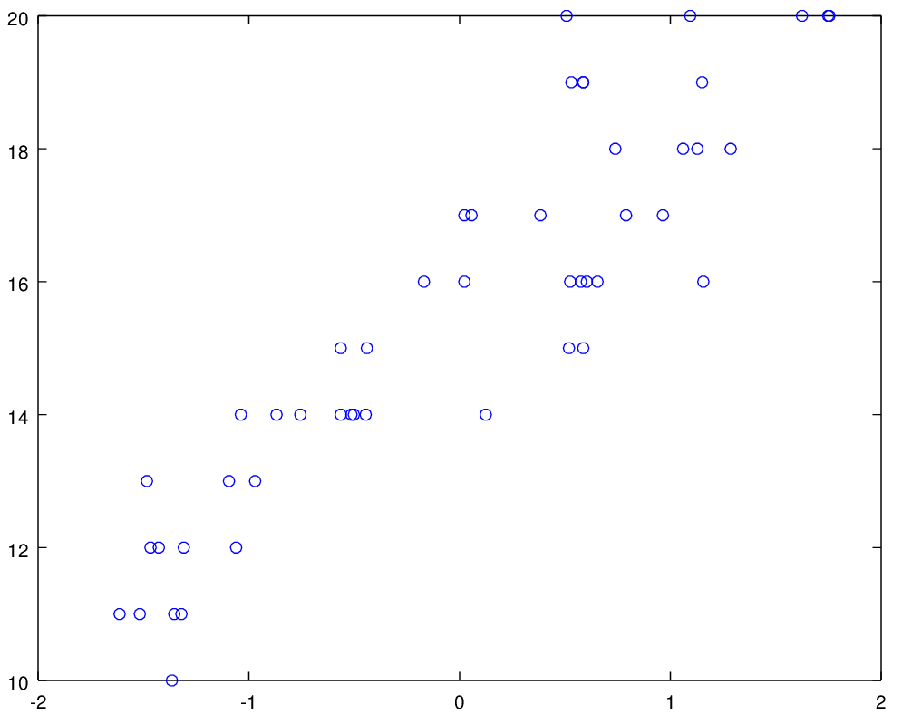
Fig. 11. Preprocessed Data Plot Age with Respect to the Height After Preprocessing.
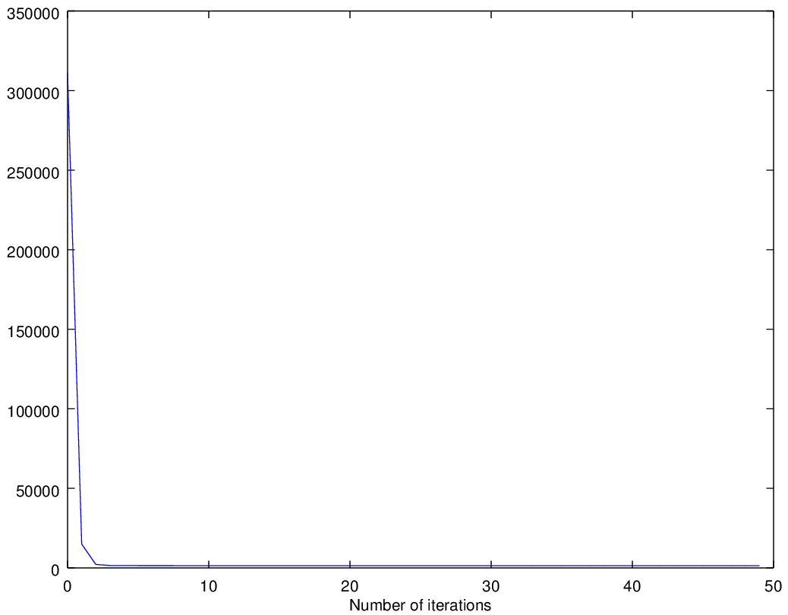
Fig. 12. Plot of learning curve rate of α=0.01.
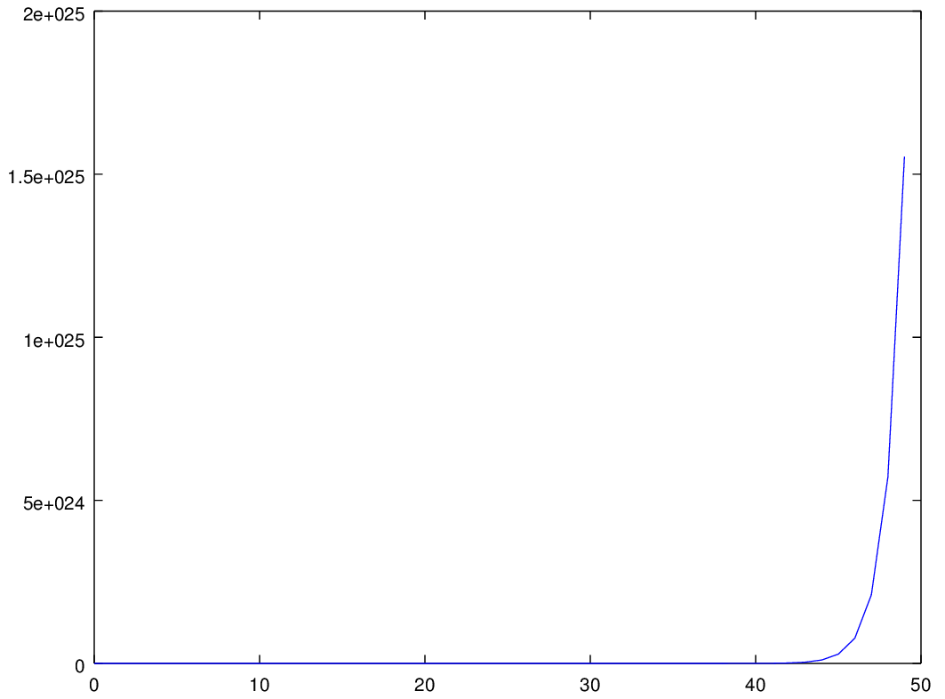
Fig. 13. Plot of learning curve rate of α=1.5.
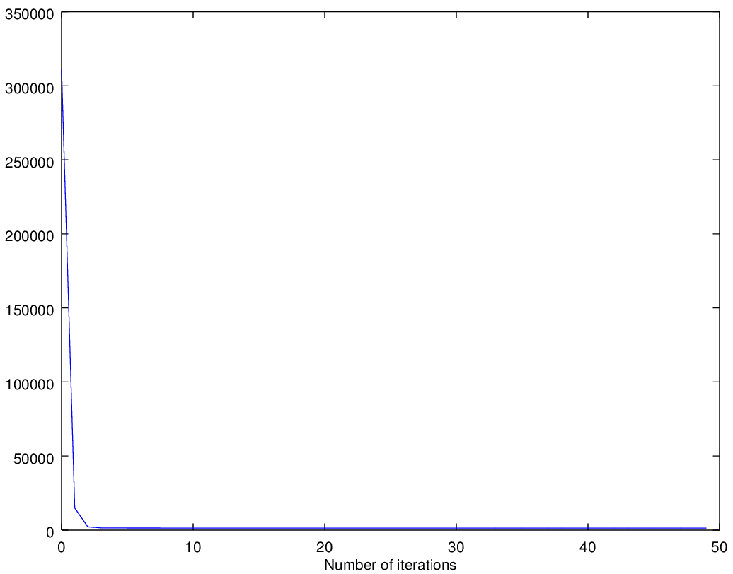
Fig. 14. Plot of learning curve rate of α=0.8.
- Procedure 2.2
ϴ = [1.5520e+001;-9.7813e+010;-9.7813e+010]
- Procedure 2.3
ϴ = [15.52000;0.80259;1.93166]
Same? Yes
- Codes
x = load('ex2x.dat');
y = load('ex2y.dat');
plot(x(:,1),y,'o');
plot(x(:,2),y,'o');
x = [ones(50,1),x];

%preprocessing

sigma = std(x);
mu = mean(x);
x(:,2) = (x(:,2) - mu(2))./ sigma(2);
x(:,3) = (x(:,3) - mu(3))./ sigma(3);
plot(x(:,2),y,'o');
plot(x(:,3),y,'o');

%cost J

alpha = 0.8;
j = zeros(50,1);
theta = zeros(size(x(1,:)))';
for num = 1:50
j(num) = (0.5 * 50) * (x * theta - y)' * (x * theta - y);
theta = theta - (alpha / 50) * x' *(x * theta - y);
end
figure;
plot(0:49,j(1:50),'-');
xlabel('Number of iterations');
ylabel('Cost j');

analysis and conclusion
In this experiment, the students enhanced their experience on utilizing the octave software in linux to analyze multivariate linear regression models. Experiment 1 was about linear regression wherein two variables x and y were used to formulate the graph and predict the value of a response using a few predictors while in this experiment regarding multivariate linear regression, it is used to predict value of one or more responses from multiple predictors.
Gradient descent is still used for this experiment to compare the computed values with the equations. Students also learned that verification of the correctness of the process can be done by comparing the gradient descent with the given equations. When the gradient descent is almost equal to the given equation then it is most likely to be correct.
In procedure 2.0 and 2.1 the curve of the learning rate denoted as alpha (α) was graphed and it was identified that a small learning rate had a downward linear graph (\), a large learning rate had an ideal graph which spiked upward at a later time while the best learning rate had a curved (() graph.
Overall, simulating multivariate linear regression was also hard to implement as students were not yet familiar with it. The tasks provided in this experiment gave meaningful insights and experience for the students for use in their future careers.

References

- MathWorks. (N.A.). MATLAB - The Language of Technical Computing. [Online]. Available: http://www.mathworks.com/
products/matlab/
- Eaton, J. (N.A.). About GNU Octave. [Online]. Available: https://www.gnu.org/software/octave/about.html
- Y. Personnel, "Yale Education," Yale University,[Online].Available: http://www.stat.yale.edu/Courses/1997-98/101/linreg.htm
- DLSU. (N.D.). Ml2 Activity: Multivariate Linear Regression [File] Available: ML2.pdf
- Andrew Ng. Stanford University, CS 229. Machine LearningCourse Materials. [Online]. Available: http://cs229.stanford.edu/materials
.html

